*The application of data mining with BCI for Service Design

**（一）計畫中文摘要。（五百字以內）**

隨著服務設計越來越重要(例如 Design Thinking 和 double diamond model)，很多公司或設計團隊利用這樣的設計流程來提升現有的服務體驗。也因為服務是一趟旅程，所以顧客在旅程中的所有感受對服務設計來說變得相當重要。然而，現有的服務觀察存在一些限制。第一，這些方法或技術受限於使用方式和效率，使得無法記錄完全的顧客體驗旅程，或要花費大量人力和成本才能取的這些資料。第二，有時顧客需要專注地體驗而不能收到干擾，抑或被干擾後就不是顧客原始的體驗心情，這可能導致服務設計結果跟顧客期望有落差。第三，就以一般觀察者觀察的技巧，無法達到像專業臉部表情觀察員那樣的精準。基於這些限制，我們在此計畫中想要產出一套新的方法論，結合現有的可攜式EEG (Electroencephalography)腦波裝置和服務設計，以彌補以上舊有技術和當今環境的落差。

第一年我們會建立一套系統，可以讓EEG裝置的腦波資訊可以藉由網路儲存到資料庫。我們會設計一套實驗來收集偵測到的受試者反應資料，利用IAPS (International Affective Picture System) 系統中的多元圖片去激起特定的情感，再藉由SAM (Self-Assessment Manikin) 表來衡量情緒是否被喚起。第二年，我們會以edX線上教育為例，將受試者分成兩群，其中一群利用我們所設計的情緒辨識系統，將影片片段做情緒標示。最後在比較利用此系統及沒有利用此系統的短期記憶表現是否有差異。

此專案會對學術界提出一套新的同理心方法論，讓一般研究者可以在面臨我們所提的情境時也可以記錄情緒旅程。在實務中我們提出一套新的服務，讓線上學習能夠更有效率。這個專案體現了服務科學跨領域的研究方法。

**（二）計畫英文摘要。（五百字以內）**

As the service design becomes more important, many companies or design teams would follow the design thinking or double diamond model to improve their customer value. First of all, a service design team needs to well understand their customers’ needs via acquiring the information of customers’ feelings and expectations in a service journey. There are many methodologies could be used for this phase. However, these methodologies based on the legacy techniques may not be able to record the situations when customers want to stay focus on their tasks without interruption, or they may spend lots of time on service which is infeasible for researchers to acquire and then map onto the customer journey. Moreover, it’s hard for general people to judge the emotional state of customers with their limited knowledge. In this work, we want to create a new methodology for detecting customers’ emotional states via EEG (Electroencephalography)-based BCI devise. We will combine single dry sensor EEG devise, emotion recognition system and customer journey map for recording customer emotion journey to provide visual map for service design.

In the first year, we will build an emotional state classification system by taking the brain wave data from EEG devise and transmitting data from EEG devises to mobile devices, such as smartphone or pad. After this, we will design an experiment to train a neural network classifier using the emotional states as classes obtained from Self-Assessment Manikin (SAM), where the emotion is triggered by International Affective Picture System (IAPS). The input data are alpha and beta waves which are time-dependent window with a time frame of 5 seconds. In the second year, this methodology would be tested with edX online learning system via testing student’s short-term memory scores if they have been facilitated by review service powered by emotional state detection and feedback systems. We plan the experiments, in which the participants will be divided into two groups and then conduct online learning activities in a physical learning context, such as a library. One of two groups as a manipulated group will use the proposed emotional state detection and feedback services to facilitate the review of learned contents; the other group is a controlled group without the review facilitation. From the experiment, we will assess the learning effectiveness via quiz by comparing the scores obtained by two groups.

For academic contribution, this work will generate a novel emotional state classification system as an extended methodology for service design via wearable EEG device. For business world, we will develop a new e-service in online learning communities that individualized and self-guided learning practice can be realized via the proposed emotional state recognition and review facilitation systems. At the end, this study demonstrates the interdisciplinary approach for service science research.

**1**. **Introduction**

**1.1 Research Background**

**1.1.1 Service design**

Experience economy is getting more important because more people are willing to spend more time and money on gaining special experiences in addition to goods consumption (Pine and Gilmore 1998). In recent years, there have been many methods for designing customer experiences developed in service design communities. The emerging issues faced by service designers are how to connect customer value which could be identified via service design process with business value which could be specified by business executives. The investment done by a service organization may be in vain if it cannot fulfill customers’ needs via the service delivery process which in general consists of numerous assets, processes, people, and materials (Goldstein, Johnston, Duffy, and Rao 2002).

Experience perceived by customers in the constituent touch points is the key determents of customer satisfaction, and in turn, influencing customers’ loyalty to the service provider. A systematic approach is needed for a service provider to upgrade existing service or create new services in order to effectively create value for customers and also maintain its financial health in service innovation. For a service provider to design customer experience, it is essential to analyze every touch point to know what customers really experienced (Spengler, Wirth et al. 2010) .

There are various service design methods nowadays. Different designers manage the design process by choosing various methods and tools for different stages. Among different methods, but the double diamond model capture the most commonly stages of a design process. They are discovery, definition, development, and delivery. In discovery stage, many tools, such as cultural probe, shadowing, customer experience journey, etc. have been used in specific situations. The precision of capturing customers’ needs in the discovery stage is essential for the success of follow-up service development. Therefore, the importance on enhancing the effectiveness of discovering customers’ needs cannot be over emphasized.

**1.1.2 EEG-based BCI wearable device**

The retrieval of signal directly from the brain has been researched for decades. In past years, a Brain Computer Interface (BCI) has been widely studied. A BCI is a non-muscular communication system that a person can use to directly communicate his/her intent from the brain to the environment (Wolpaw, Birbaumer et al. 2002). The most commonly recognized application of BCI is for individuals who lose abilities to control their muscles to be able to operate machines in their daily lives without physically entering commands (Vidal 1973). By this way, people can save time to command computer and provide disability people to express themselves.

There are many types of BCI device, e.g., invasive, partially invasive and non- invasive. What we choose for this study is a non-invasive method, which is safer and quicker to install on the head of a subject. There are three kinds of non-invasive technology, EEG (Electroencephalography), fMRI (Functional magnetic resonance imaging) and EMG (Electromyography). Considering the cost and maturity, we choose EEG to be our research tech. Usually, experimental EEG is multi-electrode, medical grade, high price and needed be set on head with gel. But there are several new companies, such as Emotiv and Neurosky, making low-cost EEG devices to allow people to wear EEG while they can freely move. We chose NeuroSky Mindset™ (2009) as the devise in this study. NeuroSky has developed a non-invasive, dry, biosensor to read electrical activities in the brain to determine the states of attention and relaxation. Another reason is because single dry EEG sensor is more available for subject to wear to move freely, which can detect the brain activities while the subjects are moving. This device can filter noise and decomposed frequency into 8 bands (high alpha, low alpha, high beta, low beta, high gamma, low gamma, delta, and theta) and each band stands for different meanings (NEUROSKY 2009).

**1.2 Research Motivation**

In the double diamond model, discovery is the first stage that can affect the outcomes of the follow-up stages. There are many ways to research customer experience, such as cultural artifacts, field studying, shadowing, customer journey, interview, and so on. In the context that a researcher cannot participate in the scene with the studied subjects, an automatic recording method could be useful, such as audio/video recording. However, to capture a subject’s emotion beyond his/her facial/vocal expression needs the facilitation of BCI type of devise. Specifically, the following three situations may need the usage of BCI facilitation. First, when a subject needs to focus on something or very busy, *e.g*., driving or taking roller coaster, s/he can’t record the emotion status at the same time. Second, when a subject has to spend times on recording their states, it may lead them to record what they think it’s important, and ignore other points which may important, too. Third, several discovery methods could be used to record a subject’s emotion via facial recognition, but this method needs specific knowledge and techniques for facial recognition, and is costly if the customer journey is very long.

Therefore, this project is positioned to adopt BCI techniques to enhance service discovery stage of service design process by recording a subject’s emotional states via mobile device on his/her touch points of the customer journey. In order to effectively apply BCI for a customer’s emotion detection, we have to validate the classification of a customer’s emotional state. A machine learning approach for training a classifier will be developed in this study in order to supply a viable classifier for emotional state detection.

**1.3 Research Objectives**

In this project, we plan to achieve two research objectives. First, we will build a service that can cost effectively detect a user’s emotional state while emerging in the e-service context without interrupting the user’s interaction with the service delivery. In achieving this objective, we plan to develop an automatic classification system, which is training by experiments set up in various e-service contexts to obtain interaction episodes with users’ reaction. A set of machine learning techniques in classification would be candidates to develop the classifier for emotional state detection. We then will build an app on mobile devices, such as smart phones or pad, as the service interface for connected applications in service design stages.

Second, we will apply the developed emotional state classifier to integrating with various stages of service design process in order to enhance the effectiveness of customer needs identification and service prototype testing. We’ll map customer emotion into customer journey via recognizing EEG data and analyze the emotional state transition during the customer journey using the emotional state classifier. Then, we can justify the cost and effectiveness of adopting EEG-type of emotional state detection for better service design outcomes via a series of comparative experiments before it can be used for regular practice.

**2. Literature review**

**2.1 Service design process**

Design has already played an essential role in many success leading companies. Design council studied eleven world top design teams and developed the double diamond model (also called 4D model), which divides service design process into four distinct phases: *discover*, *define*, *develop,* and *deliver* (Design Council, 2005).

We describe each step as follows. The first quarter of the double diamond model marks the start of the design process. This begins with an initial idea or inspiration, often sourced from a discovery phase in which user needs are identified. Before inspiring ideas, we have to gather enough background knowledge and regularly updated information about a product or service. After gathering these types of information, a design team could use for defining the problem faced by the customers by analyzing obtained information. The second quarter of the double diamond model denotes the definition stage, in which interpretation and alignment of these needs to business objectives is achieved. A design team could identify the problem which will drive the design team to specify the potential value created from the generated product or service. The end of the definition phase is the time to make go or no-go decision with detailed understanding of the potential market for the new design, together with a good idea of the cost and complexity of realizing the idea. The third quarter marks a period of development where design-led solutions are developed, iterated and tested within the company. To solve a complicated problem, it is essential for the design team to equip the multidisciplinary working capability develop solutions from many perspectives. When developing new services, it is important to test concepts with prototypes, and to seek feedback from customers. The final quarter of the double diamond model is the delivery stage, where the resulting product or service is finalized and launched in the target market. In this step, a design team could identify constraints of making the product or delivering the service. Then, the new service or product can be launched to test the market and improve the service and product based on the feedback from customers.

Another popular service development process is design thinking, which is a solution based methodology for creative resolution of problems. A design thinking process consists of five stages, *empathize, define, ideate, prototype*, and *test,* aiming to generate a prototype of product or service (Stanford d.school’s Design Thinking Resources Center). First, as a service designer, we empathize with users to recognize their physical and emotional needs by understanding the way they do things and why, what they think about the world, and what is meaningful to them. It could be viewed as a process of sensing and leading to the process of sense making mainly in define mode. Second, we all agree that a right solution comes from the framing of the right problem; thus, the goal of the definition stage is to draft a meaningful and actionable problem statement, which is also called a point-of-view. In the definition stage, the endeavor is to synthesize scattered findings into insights. Third, the ideation stage is aimed to generate ideas. Ideation supplies the fuel and source materials to build the prototypes and then create potential solutions to tackle the problems and satisfy users’ needs. In the ideation stage, it is very important to separate the generation of ideas from the evaluation of generated ideas. Fourth, quickly create a draft or prototype to present generated ideas. The prototype mode is an iterative generation of solutions including artifacts and processes intended to fulfill the users’ needs. Fifth, the test step is to solicit feedback from experiencing the prototypes built, which can gain the opportunity to empathize target user groups for whom we have been designing. These five stages are iterative until the tested prototyping products or processes can reach user groups’ satisfaction, and move toward the production stage of goods or services.

The first step of both methodologies mentioned before are essential for the follow-up steps. Since all steps are connected, the more accurate discovery of customers’ needs, the more possible that the generated products or services meeting their needs. In the initial stage of service design, among many methods existing for real world practice, the following approaches are commonly used for identifying customer behavior (Kumar 2012):

* Cultural probe: Sometimes, it is infeasible to stay around subjects to get the information on customers’ contextual interaction. To conquer this difficulty, the cultural probe has been adopted for subjects to record their contextual information with cultural probe tool kit in the scenes they emerge. A cultural probe tool kit usually contains a camera, journal, video recorder for subjects to record things s/he sensed or thought and feeling they experienced. The tool kit also includes some tasks that they are asked to accomplish, sometimes.
* Field visit: Service designers could obtain the first hand information on customers’ behavior by spending time with these subjects in real world contexts. A field visit, unlike survey or interview, emphasizes on the observation and inquiry about what is being observed.
* Shadowing: This method requires researchers to immerse themselves in the lives of subjects in order to observe their behavior in interacting with the contexts they encountered.. Researcher can record subject journey and behavior with video, text or photographs. This method is also a useful technique for identifying those people may say one thing, and yet do another (Stickdorn and Schneider 2010).
* Customer journey maps: This method provides a structured visualization of a service user’s experience upon their experience. All touch points are going to be identified first, and then we can record what customers do when they access the service. With this method, a researcher can easily identify the problems occurred in the customer journey and compare the service perceived by customers between with what obtained from competitors.

The aforementioned methods may be suitable for different situations. However, none of them can precisely record the emotional states of subjects while interacting with contexts during the customer journey, which makes the efforts of acquiring real time emotional states nontrivial.

**2.2 Non-invasive Brain Computer Interface**

There are three major and popular ways for recording human brain activities in both experimental and medical purposes using non-invasive brain computer interface. These are Electroencephalography (EEG), Electromyography (EMG) and Functional Magnetic Resonance Imaging (fMRI). All of these techniques have been researched for decades and many papers from Journal of Neuroscience or NeuroImage are based on these methods.

**2.2.1 Electroencephalography (EEG)**

Electroencephalography (EEG) is a way to record neurons electrical activity by setting electrodes on a person’s scalp to measure the voltage fluctuation over a period of time (Niedermeyer and Silva 2004). When the brain wave, which is made by ions, reaches the electrodes, they can be captured by electrons on the metal on the electrodes. Because metal conducts the push and pull of electrons easily, the difference in such change of voltage can be measured by a voltmeter and then recorded over a period time, which muscle noise have been filtered, gives us the EEG (Tatum, Husain et al. 2008).

The EEG could show brain activity in terms of rhythmic activities and transients. The rhythmic activity usually is decomposed into several specific bands by frequency. To some degree, these frequency bands have nomenclature. Frequency bands are usually extracted with eight bands via FFT (Fast Fourier Transform) as below:

1. Delta waves were defined as the frequency range up to 4 Hz. It is prominent frontal in adults and babies in slow wave when they are deeply sleeping. The wave is associated with seizure-like activity in the brain.
2. Theta waves were defined as the frequency range from 4 Hz to 7 Hz. Theta is bound normally in young children or may be found drowsiness or arousal in older children and adults; it can also be seen in meditation (Cahn and John 2006).
3. Alpha waves were defined as the frequency range from 7 Hz to 14 Hz. Hans Berger (1924) named rhythmic EEG activity he saw as the "alpha wave". Alpha waves are the "posterior basic rhythm". It predominantly emerges when subjects close eyes and with relaxation, and reduced when subjects eye opening or mental exertion (Klimesch 1999, Vladimir, Ruth et al. 2001).
4. Beta waves were defined as the frequency range from 15 Hz to about 30 Hz. It is found usually on both sides in symmetrical distribution and is predominantly evident frontally, which is closely related to motor behavior and is generally minimized during active movements (Pfurtscheller and Lopes Da Silva 1999). This wave is also related to active, anxious thinking, or active concentration.
5. Gamma waves were defined as the frequency range approximately 30–100 Hz. The rhythms are related to represent gathering different populations of neurons into a network for performing a certain cognitive or motor function. Also, when these neurons clustered together, they will assist to bring up memories and associations from the visual perception to other notions.
6. Mu waves were defined as the frequency ranges 8–13 Hz. Sometimes this wave partly overlaps with other frequencies. The mu wave usually is found over the motor cortex which can control voluntary movement. The wave predominantly emerges not only when a subject is in active movement but also shows up when the subject observes the movement by others.

From the prior research, the normal electroencephalography varies by ages and individuals. An individual shows different shapes of electroencephalography even in the same context. Thus, the same band between different individuals cannot be compared directly.

**2.2.2 Electromyography (EMG)**

Electromyography (EMG) is a way for evaluating and recording the electrical activities triggered by skeletal muscles using an electromyogram. When the muscle is contracted, the waves triggered by muscles will appear as a disorderly group of action potentials of rates and amplitudes. An electromyography can detect the electrical potential produced by muscle cells when these cells are activated.

The shape of electromyography can be separated into two categories: surface electrodes and needle electrodes. The shape of surface electrodes looks like interferential signals, where a needle seems to present some periodicity. The electrode is retracted a few millimeters, and again the activity is analyzed until at least 10 motor units have been collected. Each electrode track can only provide a very partial and local picture of the muscle activity from the whole muscle picture. Because of the difference between skeletal muscles and inner structure, the electrode has to be placed at various locations to obtain a whole picture of specific part to provide more accuracy of a study (Allen, Harmon-Jones et al. 2001).

**2.2.3 Functional Magnetic Resonance Imaging (fMRI)**

Functional Magnetic Resonance Imaging (fMRI) is a functional neuroimaging procedure using to measure brain activities. With MRI technology, we can get high-resolution pictures by detecting the changes of brain while blood flowing. This technique relies on the fact that blood flow is strongly related to neuronal activation. Blood flow increases in a specific part of brain when this area is in use.

The fundamental principle of detecting is that the fMRI uses the blood-oxygen-level dependent (BOLD) contrast (Ogawa and Lee 1990). The change in the MR signal from neuronal activities is called the hemodynamic response. This method lags the neuronal events triggered about 2 seconds, because it needs to take a time for the vascular system to respond to the procedure that brain gets glucose, so that a peak which could be detected needs about 5 seconds after the stimulus. The peak will spread to a flat plateau while the neurons stay active (Huettel, McCarthy et al. 2009).

However, fMRI has some risks and backwards. An fMRI test may lead participants to have Claustrophobia and the radioactive is risky for pregnant women when they are in the scanning process (Sahito and Wolfgang 2012). Also, in the scanning process, the high-pitched noises and gradient switching could lead to uncomfortable feeling.

From the information presented in the above subsections, we can compare the difference among these three brain data acquisition methods. EMG needs to set several sensors on facial muscle to detect facial emotion which is not suitable for outdoor context. fMRI can provide high resolution pictures of brain activities with high precision, but the output would delay 5 second before we can formulate the results. Moreover, fMRI device is very expensive. Compared to these techniques, EEG is relatively more suitable for our work aiming to detect emotional states in mobile settings because it is portable and affordable devise, for example, NeuroSky and Emotiv are more acceptable for the general public.

**2.3 EEG-based Emotional State Recognition using Classification Techniques**

Data mining is a set of techniques to discover knowledge from data or find rules in a huge database. There are two basic methods in data mining: classification and clustering. For classification, a model is trained via feeding a set of observed examples with tagged classes to identify patterns from the data. Clustering different from classification does not need to tag classes on data first. Clustering is the process of grouping a set of data objects into multiple groups or clusters, so that objects within a cluster have high similarity, and at the same time, it is very dissimilar between objects between different clusters (Han 2005).

This work focuses on the classification task. Among various classification techniques, we identified classifiers which are popular in neuron science field as our candidate classification techniques for building EEG data classifier. Table 1 summarizes the prior works done by researchers in building EEG data classifiers.

Table 1. Prior works on EEG data classification

|  |  |  |  |
| --- | --- | --- | --- |
|  | Classifier | Attributes | Description |
| 1 | Naive Bayes binary classifier | Attention and mediation from Neurosky MindBuilder-EM with 20s frame with 10s overlapping. | Subjects were asked to fill SAM, which is assessed by valence and arousal after playing a brain-controlled video game. After experiment, the serial of mediation and attention were transformed into the mean, standard deviation, maximum, minimum, and slope then become features. The most recognized emotion were engaged (69.59%) and neutral (64%) (Yoon 2013). |
| 2 | Neural network with back propagation and Levenberg- Margardt algorithm | Wavelet transformation of Delta, Theta, Alpha and Beta with 3s frame. | Classification of EEG via using epileptic seizure or non-epileptic seizure data and retrieve several bands coefficients by wavelet transform, which considers both frequency and time, and train this ANN with back propagation algorithm. Also, they found the optimum number of nodes in hidden layer is found as 21 In this work, they assess the performance by sensitive and specificity, both are above 90%. Besides, this work also compared the ANN with logistic regression, and ANN obtained higher accuracy in classification (Subasia and Ercelebi 2005). |
| 3 | k- Nearest Neighbor classifier | Beta/Alpha ratio with 4s frame. | Assess subjects’ depression degree via EEG signal with two electrodes set in left and right frontal lobe, because in previous studies show that the left hemisphere is good at processing positive emotions, whereas the right hemisphere is more related to process negative emotions. The total number of correct claimed client achieves 100% (Peng, Hu et al. 2011). |
| 4 | Neural network with back propagation | Alpha and Beta band | Classify two motor images from two electrodes set in left brain and right brain. In the neural network, this work add he classifier contain finite impulse response filter between the nodes to consideration time series with dynamic weight adjust. This filter could process different data with different via given different time coefficients. In this way, the time variable could be process without process before feeding into classifier (Haselsteiner and Pfurtscheller 2000). |
| 5 | Neural network with mutual information | EEG raw data from 16- channel with 80s frame | This work uses the difference of time delay between epilepsy and non-epilepsy EEG data which is produced via mutual information, then fed into probabilistic neural network (PNN) classifier. The accuracy of this work is 100% (Yuan, Li et al. 2008). |
| 6 | Neural network and k Nearest Neighbor approach | Spectral entropy and spectral centroid from Alpha, Beta and Gamma which were retrieved by FFT with 5s frame. | Five emotions were defined before, and elicit emotion via video clips. Final result is that KNN performs well than PNN with almost same accuracy but lesser computation time (Murugappan and Murugappan 2013). |
| 7 | k Nearest Neighbor classifier | Alpha and Beta with time domain feature (*i.e*., statistical-based features and higher order crossing) and spectral domain features(*i.e*., wavelet transform) | In this work, they use Emotive epoch this device to record EEG data with 14 channels. Eliciting subjects’ emotion with IAPS system and assess arousal degree of emotion via SAM to quality training data. They train KNN classifier with 5-fold cross validation. The emotion recognition rate of 5NN is 77.44% (Xu and Plataniotis 2012). |
| 8 | Neural Network | EEG original raw data with sampling rate once per second. | This work records signals from positions P3, P4, C3, C4, O1, and O2 electrodes defined by the international 10-20 systems. They used ANN by virtue of its principal characteristics of learning by example and simplicity. (Kottaimalai, Pallikonda Rajasekaran et al. 2013). |
| 9 | Neural Network | The signals were sampled at the rate of 256 Hz. 64 channels | Five emotion: anger, happy, sadness, neutral, surprise. The classification of only 2  types of emotions (neutral and sadness)  produced the highest percentage of correct  classification at 97.50%. The percentage  is then followed by the classification of  3 emotions, 97.20%, 4 emotions, 95.42%  and 5 emotions, the lowest performance at  95.00% (Yuen, San et al. 2009). |

2.3.1 Bayes Classifier

Bayesian classifiers are statistical classifiers. They can predict probabilities between different class members, such as the probability that a given tuple belongs to a particular class. Bayesian classification is based on Bayes’ theorem, which is based on mathematical conditional probabilities. It is denoted as given an incident X occurs.

2.3.2 Supervised Artificial Neural Network

Artificial Neural Network (ANN) is an information processing method which is inspired by a neuron interaction in a nervous system. The pattern of ANN consists of three kinds of layer, input layer, hidden layer and output layer. Each layer made by several nodes embeds weights and threshold to connect to the nodes of its neighboring layer. Figure 1 illustrates the structure of an ANN.

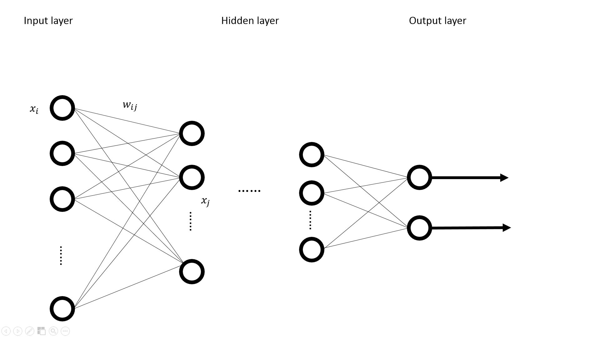

Figure 1. The general structure of an artificial neural network

* The input layer: The input data simultaneously is fed into the nodes of this layer and counted via weight.
* The hidden layer: The input data from the input layer have been reconstructed and passed value to the next hidden layer, and so on. A neural network usually contains one or two hidden layers and then feeds the values to the output layer.
* The output layer: This layer is a tuple that output the classes the input tuple is classified to.

The efficiency of ANN is highly related to the learning algorithm. Back propagation (BP) ANN is one of the learning algorithms based on gradient descent as weights change.

2.3.3 K-Nearest Neighbors

This classifier is trained by labelling a point with a class which is the majority of class its k nearest neighboring points belongs to by comparing the distance between points, which is data in an *n*-dimensional space. Then, if an un-labelled data object in the space can be classified into the class where its k nearest neighboring objects. This classifier is the simplest technique in classification.

After we introduced the classification techniques, we would like to investigate how these classification techniques can be used for emotional state classification. The term emotion should be rightfully used to designate a collection of responses triggered from parts of the brain to the body, and from parts of the brain to the other parts of the brain, using both neural and humoral routes. Different stimulus stuff to same subject could trigger different emotions. Emotion can be divided by two-dimensional scale, valence (positive/approach versus negative/withdrawal), and arousal (calm versus excited) into four parts (Lang and Bradley 2007). Moreover, Yoon (2013) decomposed emotion into 9 divisions based on valence and arousal into nine parts which are engaged, pleasant, relaxed, activated, neutral, clam, stress, unpleasant, bored as shown in Figure 2. Emotion can be elicited by human face picture from International Affective Picture System (IAPS), a database of colorful pictures, which was developed by the National Institute of Mental Health Center. These pictures are familiar with human daily life experience, and can be used to evoke human specific emotion (Bradley 2007). This database is supported with a number of physiological and neurological tests.

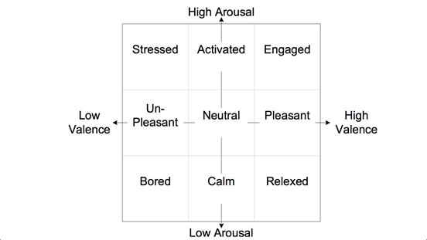

Figure 2. Emotional classification (Lang and Bradley 2007)

After eliciting specific emotional state of a subjet via EEG-based BCI wearable devise,, we can assess emotional state via Self-Assessment Manikin (SAM)(Bradley and Lang 1994). This technique can directly measure the pleasure, arousal, and dominance from a subject’s affective reaction with non-berbal pictorial assessment techique. This technique classifies a subject’s emotional states more systemicly, and very popular in neuro science.

EEG-based emotion recognition has been researched for many years. Each part of brain may present specific rhythm at different frequency ranges (Bradley and Lang 1994, Arslan, Brouse et al. 2006). For different hemispheric, left and right part have different majors in emotion. The left one is more major in processing positive emotions and active behavior, whereas the right hemisphere is more major in processing negative emotions and withdrawal behavior (Coan and Allen 2004). Henriques and Davidson (1991) observed that depressed subjects had less left-sided activation than did normal control subjects. The pattern of excessive left-sided frontal alpha activation provides an effective basis for the detection of depression.

For frontal lobe, there are several findings. The frontal cortex is particularly critical in emotional processing (Allen, Harmon-Jones et al. 2001, Seo, Gil et al. 2008). Alpha wave in frontal lobe have strong relation with human relaxation and Beta wave has string relation with alert states (Niemic 2002, Bos 2006, Bos 2007). High alpha means that brain has low activity, and low beta means brain has low alert state. Theta also has relationship with emotion. Cognitive reappraisal of aversive pictures is correlated with an increase in theta oscillations at prefrontal brain regions. This finding was observed in both, the ‘increase’ and the ‘decrease’ conditions. Furthermore, it was shown that increased theta activity was positively correlated with the success of participants to decrease their emotional response (Ertl 2013).

Here are some emotion classifications via Neurosky Mindset. Crowley(2010) compared the output from the Neurosky Mobile and observers based on Stroop Test. 32 times in 41 times tests (Neurosky device and Observers) in the same categorization, shows that we are able to assess the suitability of the NeuroSky headset for measuring the meditation and attention level of an individual. Also, Yoon(2013) used mediation and attention from Neurosky device via Naive Bayes classifier and average recognition accuracy 66.04% (Yoon 2013).

Besides, neuro reflection from brain, which is elicited by event, has strong relation with period (Coles, G.H. et al. 1996). This method is called EPR (Event-Related Potential) (Zhang, Kong et al. 2011). Attractive faces elicited more enhanced ERP amplitudes than did unattractive faces in judgment (N300 and P350–550 msec) and recognition (P160 and N250–400 msec and P400–700 msec) tasks on anterior locations. Moreover, longer reaction times and higher accuracy rate were observed in identifying attractive faces than unattractive faces.

**3. Research Methodology**

To achieve the research objectives of this project, we need to accomplish two major tasks: (1) to build an emotional state classifier in order to capture a subject’s emotional states via EEG-based BCI wearable devise; (2) to adopt the developed emotional state classifier to discovering customers’ emotion in service design process. The following subsections will describe the tentative methods and tools used for achieving these objectives.

**3.1 The Development of the Emotional State Recognition System**

3.1.1 EEG data acquisition

We will build a system for EEG data acquisition and visualization, the overview of the architecture is shown in Figure 3. A good database for developing emotion recognition system is essential for achieving the effectiveness of classification. We will collect data from a series of experiments to build a database with well-defined emotional tags.

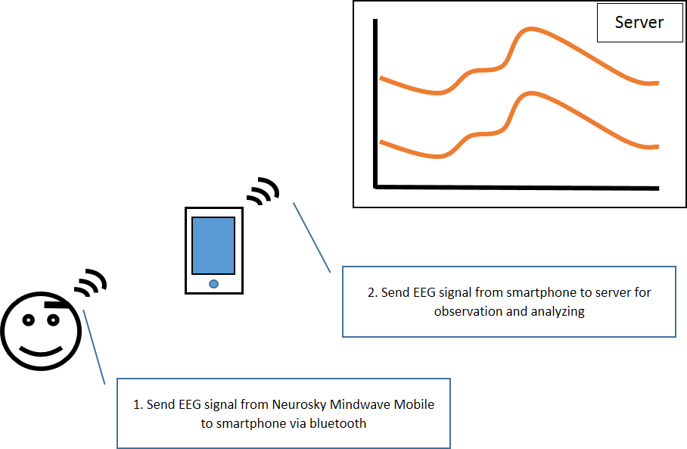

Figure 3. Architecture of Emotion Recognization System

To get EEG data, a subject will wear a NeuroSky MindWave Mobile, a wireless Bluetooth headset with only single dry electrode that was placed on the subject’s forehead. This devise provides EEG-related data, *i.e*., the strength of delta, theta, high alpha, low alpha, high beta, low beta, high gamma, low gamma per second, and attention, mediation and strength of blink value can be read from android SDK developed by NeuroSky. Figure 4 denotes an example of screenshot of current NeuroSky MindWave, which captures brain waves for additional data processing.

We will develop an android app providing colorful timestamp for receiving and mapping these data to different timestamps for marking EEG data. Because of the experimental goal is to classify emotional state, we will only record alpha and beta waves which have a strong relation with emotion according to literature review, and blink value for removing noise data.

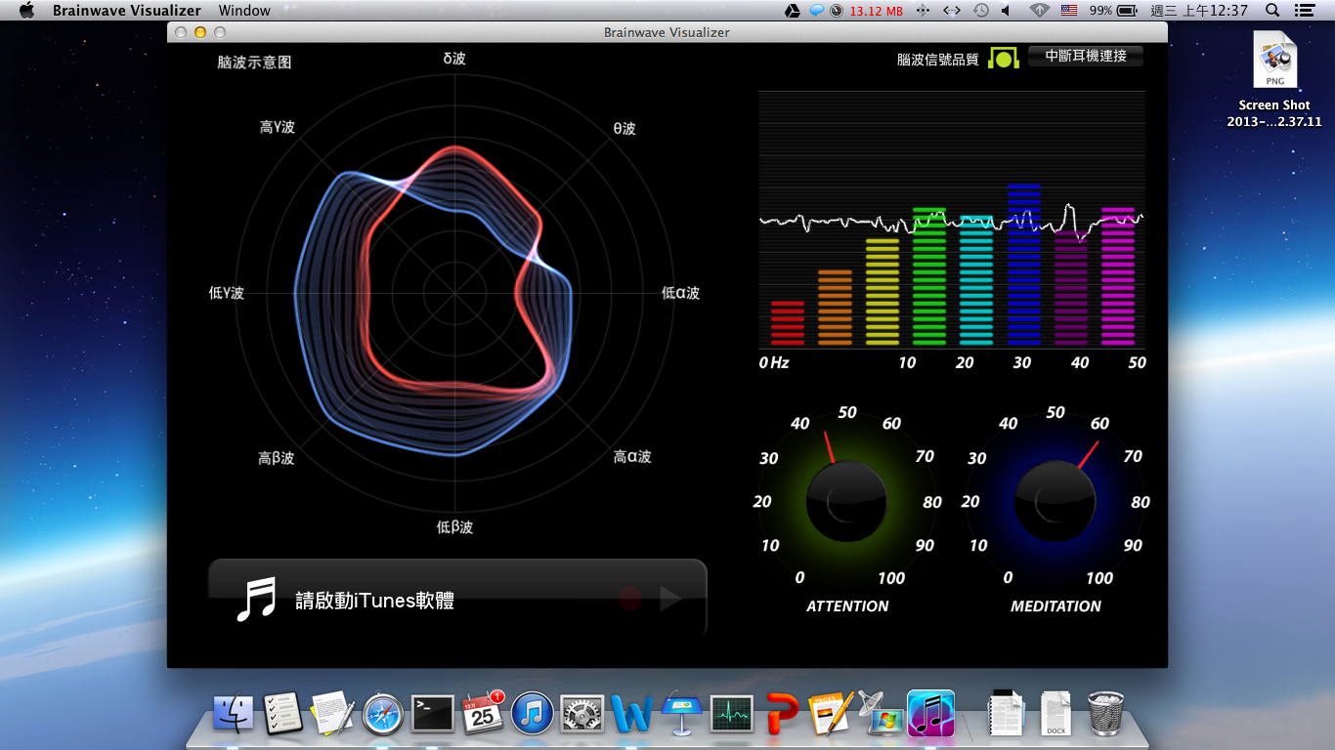

Figure 4. A screenshot of NeuroSky MindWave

3.1.2 The training of an emotional state classification model

The first thing to generate an emotional state recognition model is to build a classifier. In the work done by Subasia and Ercelebi (2005), the accuracy of the classification using neural networks is better than that using logistic regression. However the work done by Murugappan and Murugappan (2013) claimed that the KNN has better performance than probabilistic neural network, but the input of KNN is delay time of alpha and beta, which is totally different from original data. Kottaimalai (2013) conducted the classification work using neural networks by virtue of its principal characteristics of ANN in learning by doing and simplicity. Among these endeavors, the most impressive work is time-dependent neural network (Haselsteiner and Pfurtscheller 2000). It built time filter between inside nodes because there are no rule for find patterns before feeding into the neural network. There are many works about EEG classification based on neural networks, but very few studies have been done based on a novel portable EEG devise. Besides, neural network is the most popular classification methodology in BCI research (Larsen 2011). Also, Garrett, Peterson et al. (2003) found that nonlinear classifier is better than linear classifier in EEG classification. Jain, Jianchang et al. (1996) mentioned that exhibit patterns of ANN similar to those exhibited by humans, so this algorithm is very popular in cognitive sciences. Considering all potential situations encountered in this EEG data classification, we adopt neural networks as the emotional state classification model.

All data frame will be sent to a server where we are going to develop the classification model. The serial of features collected in each 5 seconds could turn into a sequent of features, as inputs to the neural network. Then, we will create ten input nodes of the neural network as only alpha and beta waves are recorded. From literature review, we knew that the features of emotion from EEG are highly related to both frequency and time. Thus, this work will also consider both two variables. Because frequency features are processed via FFT, which is a filter embedded in NeuroSky MobileWave headset, we only have to focus on time feature. We plan to use two methods to process the data captured before feeding data into a neural network.

* Use mutual information to remove time delay: Before inputting data into a neural network, we could calculate the Mutual Information (MI) of a prior labeled frame data to remove the noise feature when emotional states have not been elicited.
* Add time coefficient between nodes: We proposed a time-based approach to process features in a time frame without giving the same weights to the features collected from different time frames. For example, after we retrieve alpha waves from subjects in a five-second time frame, we set the weights for individual time frames as the multipliers for input nodes as elaborated in Figure 5. Node *O1* receives the sum of the values from input nodes multiplied by time weights and output to the next layer via transformation function, *e.g*., squash function.

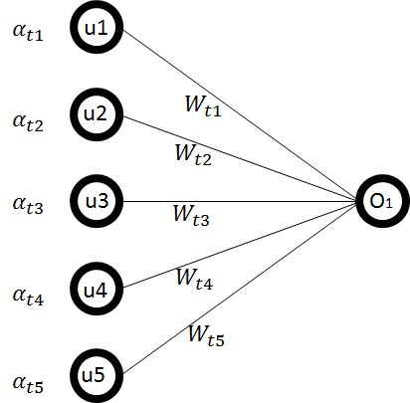

Figure 5. Time-based Neural Network

By taking the value inputted from input nodes, each node on the hidden layer will sum up the multiplications of the value of an input node with its weight. Then, the output of each hidden node is generated through a transformation function, e.g., squash function. The output nodes are four possible emotional states by taking the sources of value from hidden layer. The architecture of the neural network is shown in Figure 6.

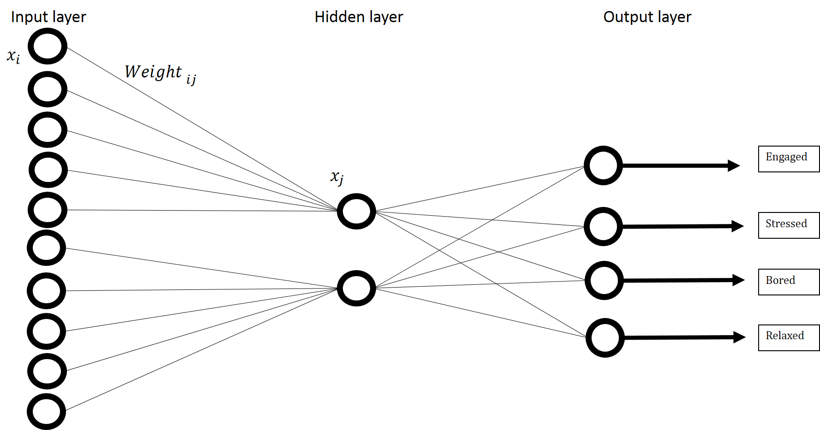

Figure 6. The time-based ANN classifier

In the experiments, the output from ANN classifier will be measured by accuracy, recall rate and precision rate. The confusion matrix for the measurement is listed in Table 2.

Table 2. Confusion matrix

|  |  |  |
| --- | --- | --- |
|  | P’ (predicted) | N’ (predicted) |
| P (actual) | A | B |
| N (actual) | C | D |

**3.2 User Experience Journey Development**

After we built the emotional state classifier, which performs above a certain level of effectiveness, we would like to apply it onto a service design context by capturing customers’ emotional states in their experience journeys. Although there have been many customer experience acquisition methods, such as contextual inquiry, shadowing, cultural probe, etc., there exists some limitations to obtain customers’ emotional states via indirect sensing mechanisms. Especially, in an e-service context, customers’ experiences in using the system may not be observed by researchers, or the presence of researchers may prohibit the occurrence of episodes which may happen naturally when the subjects are alone. According to (Doorn and Hoekstra 2013), the characteristics of e-service demands the emotional state recognition service in the following scenarios: (1) subjects spend a lot of odd moments on the e-service; (2) researcher is hard to follow subjects all the time when they are in the physical settings of using e-services, especially in a mobile environment; (3) the e-service connected via internet based on WiFi or telecom networks; (4) subjects do not want to be watched when they are doing something.

Based on the aforementioned characteristics of e-service and customers’ encountering conditions, we will design a service consisting of methods and tools for service designers to acquire customers’ emotional states during the customer experience journey in a type of e-service offering. For example, in the most current e-learning environment, called Massive Open Online Courses (MOOCs), in which an e-service platform is developed to facilitate instructors and learners to interact online. Besides the technical challenges to allow a large group of learners, sometimes more than one hundred thousand learners, to register on one single class, how to ensure the high quality of learning outcomes is also concerned. A short video clip could be viewed by a learner in order to keep the learner’s attention, and homeworks after the lecture could be used for learners to practice the skill or digest the contents in order to store in their long term memories. Moreover, how to facilitate a learner to guide himself or herself through the learning process is the key performance index of learning in the internet era, which enable a learner to become a proactive learner including s/he can manage his/her learning experiences. By investigating a learner’s experiences in a MOOC e-service via the proposed emotional state classifier, as a course designer, s/he can adjust the content flow of the course unit before delivering to the mass learning group. Moreover, as a leaner, the learning experience cycle could be enhanced to allow him/her to capture his/her emotional states to better beware his/her learning habit, so that the feedback of emotional states could guide him/her to become an effective learner. For an MOCC e-service provider, the feedback from emotional states of a learner could facilitate specific interaction design; for example, the e-service system could record the period of video viewed by a learner who is in a state of confusion, and then the e-service can refer the learner to review the video played during that period of time. This may release the load of reviewing contents for a learner via the interaction between a learner’s emotional states with service offerings.

Technically, we will install the emotional state classifier onto a learning devise, such as mobile app, and subjects as MOOC learners can wear EEG-based device, which data can be transmitted via Bluetooth to the mobile app running emotional state classifier. Through the classification, a learner could review his/her learning process with different levels of emotional states, such as bored, stressed, engaged, or relaxed. We will validate these states recorded with subjects’ retrospection via interviewing and video clip replaying, so that we can test its feasibility of real world usage in online learning contexts. By completing the prototyping and testing process, we intend to realize the technology and experimental design for service design, especially for e-service design.

**4. Experimental Design**

**4.1 Experimental Design for the First Year**

The main task of the first year project is to build an emotional state classifier in order to capture a subject’s emotional states via EEG-based BCI wearable devise. The performance of the system is highly relied on EEG data retrieved from participants. The experimental design for collecting EEG data is described as below:

* + 1. Emotion Elicitation

Many literatures we studied show that elicitor, setting, focus, and subject awareness (open recording versus hidden recording) are the factors that can affect the emotion results. So, we will design a stimulus via International Affective Picture System (IAPS) showing specific pictures on the screen to elicit a subject’s emotions under a controllable environment; for example, the spacious room with comfortable setting, and then we use hidden recording to avoid the potential intervention of the subject’s emotion.

After emotion elicitation, each subject is asked to fill out SAM form (Figure 7) by giving scores for their valence and arousal degrees. The scores from SAM could be used to calculate the means of the scores of emotional states of specific subjects.

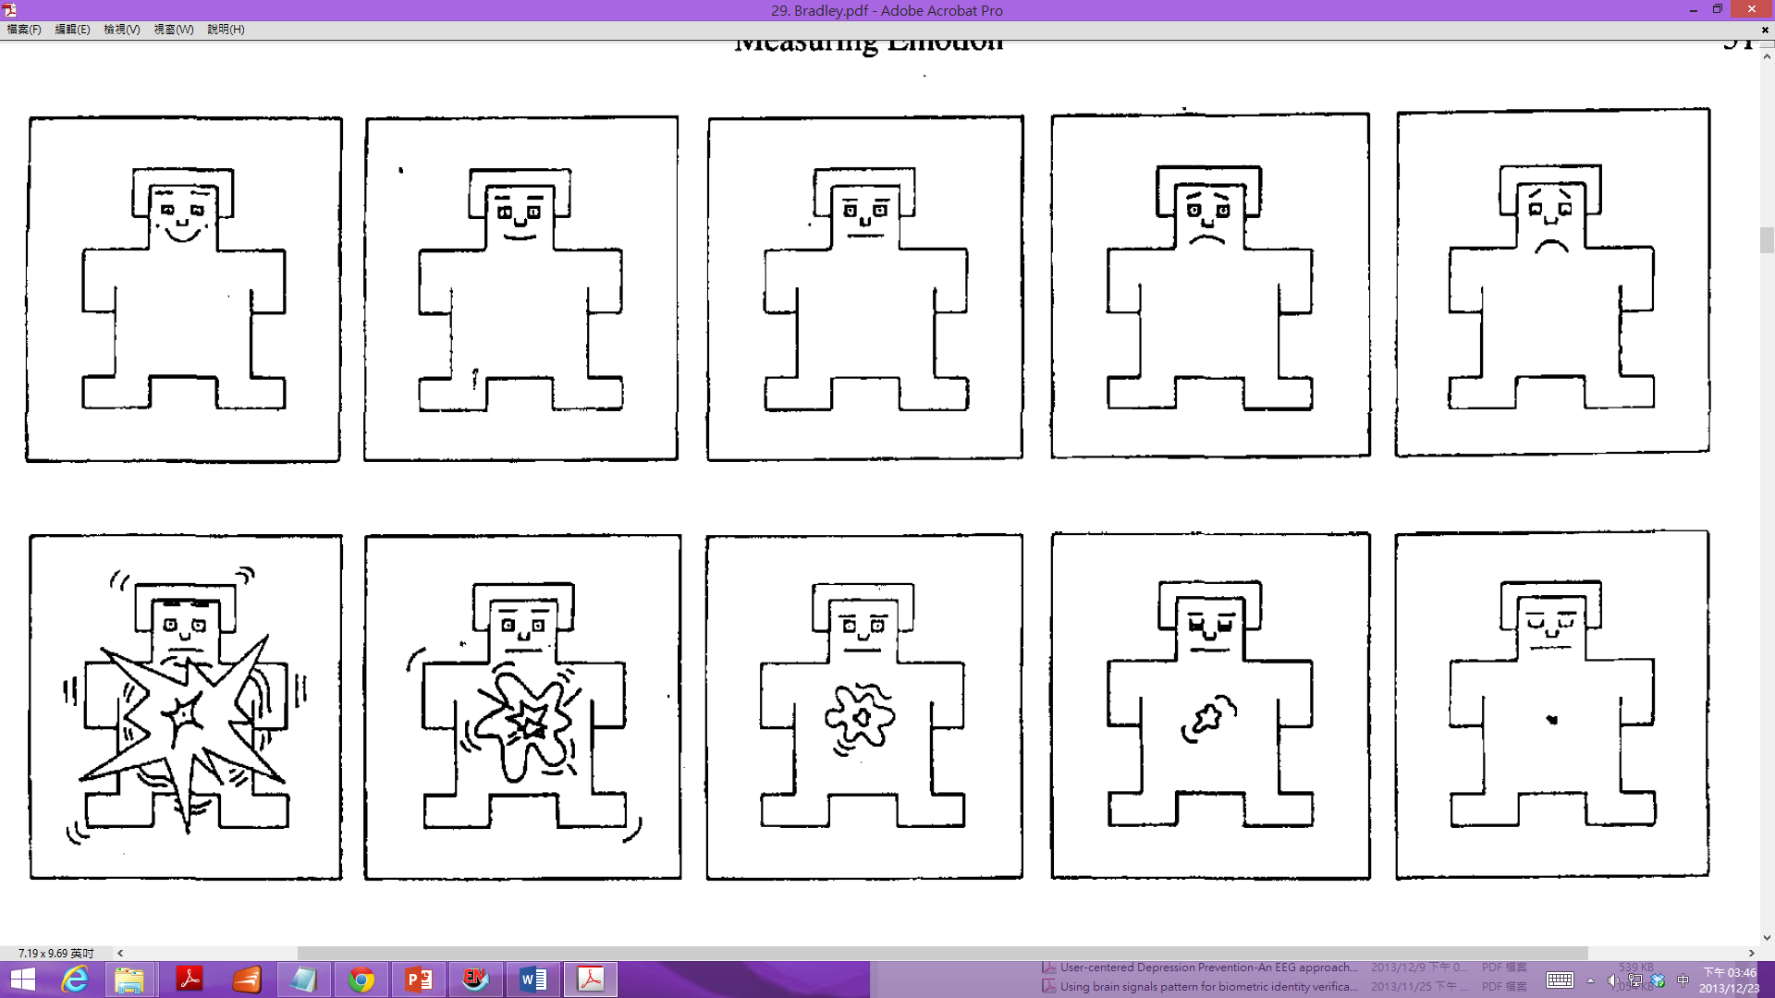

Figure 7. An example of SAM form (Bradley and Lang 1994)

* + 1. Experimental Settings

Based on Bos (2006), the emotional states based on two dimensions, valence and arousal, can be categorized in four states, namely engaged, stressed, bored, and relaxed, as shown in Figure 8.

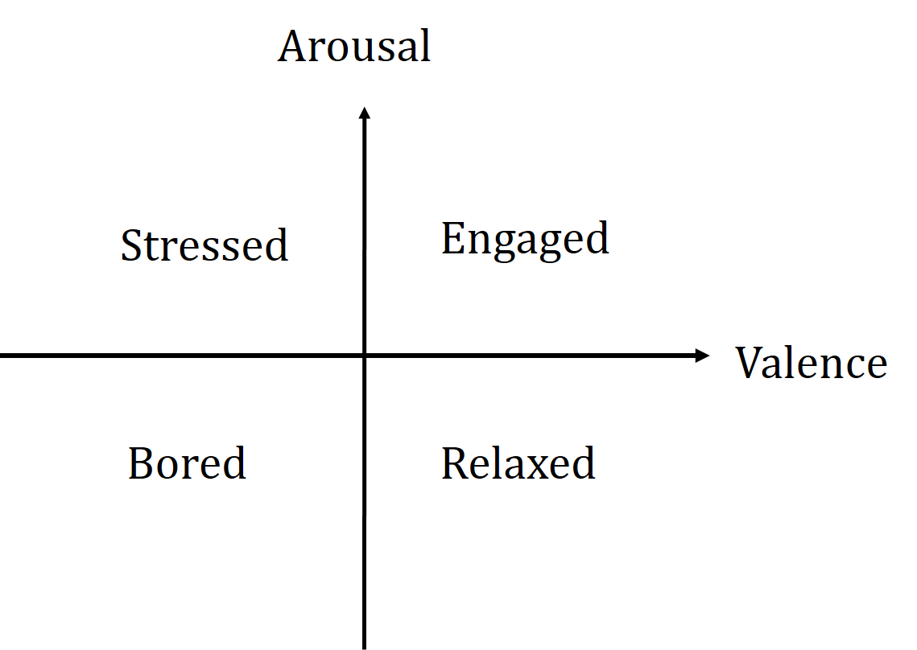

Figure 8. Emotion segmentation

Subjects will wear a NeuroSky MindWave, with a signal dry sensor settled on the forehead, to record alpha and beta waves with one sampling per second. EEG data are collected for from a five-second stimulus and then the subjects fill out the SAM scores for 30 seconds. There are four emotional stimuli in one experiment as shown in Figure 8. A subject will start the experiment by closing his/her eyes for one minute and then open his/her eyes for one minute. The eyes-closing and eyes-opening actions will rest subjects’ states to bring them back to a similar mental state.



Figure 9. Experiment procedure

* + 1. Subjects

To get enough dataset, we plan to recruit 60 individuals (30 male and 30 female), aged ranging from 20 to 25, to participate in the experiments. The boundaries between different classes are determined from the subjects’ answers to the SAM questionnaire. Once we collect EEG data from these subjects with SAM scores, we can formulate the training and testing data set. Through the time-based ANN classification process, we expect to obtain a viable emotional state classifier which meets the performance metrics in accuracy, recall rate, and precision rate.

* 1. **Experimental Design for the Second Year**

The task of the second year is to adopt the developed emotional state classifier to discovering customers’ emotional states in service design process. Thanks for the maturity of internet and technology, student could learn course everywhere without time, place and occupancy limitations. For example, MOOC (Massive Open Online Course) enables a massive population of learners to learn online. Several MOOC platforms have been implemented, such as Coursera, Udacity and edX. In reviewing the availability of the system in our research environment, we will take the first lecture of “Introduction to Public Speaking”, (course code: COMM220UWx) in edX, which is more related to everybody in different fields to avoid two situations: students have understood the subjects very well and may feel bored, or they are unfamiliar and difficult to engage with the learning activities. Since the edX service provides a distance service via video to numerous students, it’s difficult for teachers to understand each student’s learning contexts and progress. For example, students may have trouble to review the contents with a sequence of video playing, and hard to memorize the key knowledge they are engaged. Besides, every student has different levels of learning abilities, and to enable the self-guided learning is very suitable for e-service based on users’ feedback. Thus, in the second year, we would like to apply the emotional state classification mechanism to facilitate learners to better managing their learning process via interaction design.

* + 1. Subjects

We would like to recruit 64 participants of students (32 male and 32 female), aged ranging from 20 to 25. 64 subjects will be divided into two groups, namely A and B, and each group has 16 males and 16 females. Group A is a controlled group without been intervened by the learning facilitation service, while group B is an experimental group by embedding learning facilitation service based on emotional state feedbacks.

* + 1. Experimental scenarios

Before starting the experiment, the participants will be asked to conduct pretest to measure the strengths of background knowledge for each participant. Knowledge related to course subjects will be designed as a set of questions for subjects to answer before the experiment. We will train the emotional state classification system embedded in the learning system. Thus, the individualized EEG data can be used for formulated corresponding users’ emotional state recognizer when users are conducting learning activities. Then, subjects as learners will be asked to conduct the subject learning for 50 minutes with NeuroSky MindWave headset on their heads in library, where has good contexts for learning. After the learning task, a set of subject related questions will be issued to learners to evaluate their learning effectiveness.

As shown in Figure 9, Groups A and B all go through learning process for 50 minutes, and then give 10 minutes for course content review. After the review process, a set of questions are issued for both group to answer within 10 minutes. The process of 10 minute review is manipulated differently in groups A and B. Group A as a controlled group, has no reviewing facilitation, while Group B as an experimental group facilitated by the feedback from emotional state detection mechanism. In a setting where a learner watching online lecture video, the reviewing facilitation can be designed to present the video clips when the learner’s emotional state is stressed during the time period since the learner may feel difficulty in learning the contents presented in that time period. After both groups finish the quiz, we could calculate their total scores to verify whether students can benefit from reviewing feedback via emotional state detection and feedback facilitation in a level of short-term memory.

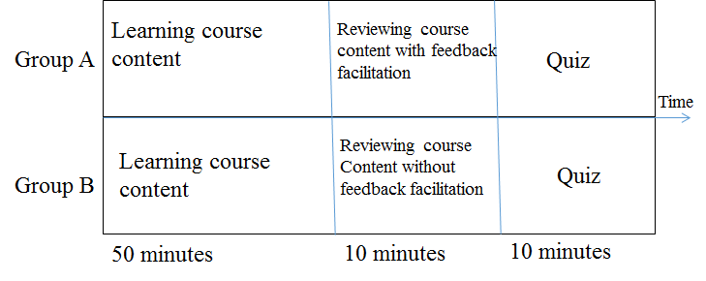Figure 10. Experimental design for e-learning settings

**5. Anticipated Contributions**

**5.1 Project Schedule**

5.1.1 First year

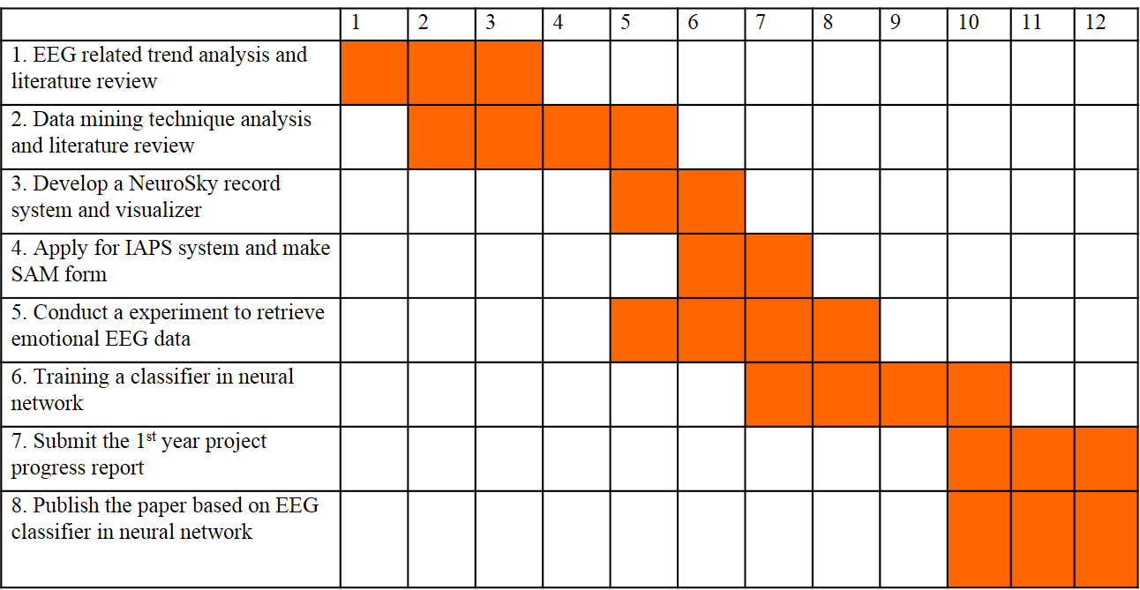

5.1.2 Second year

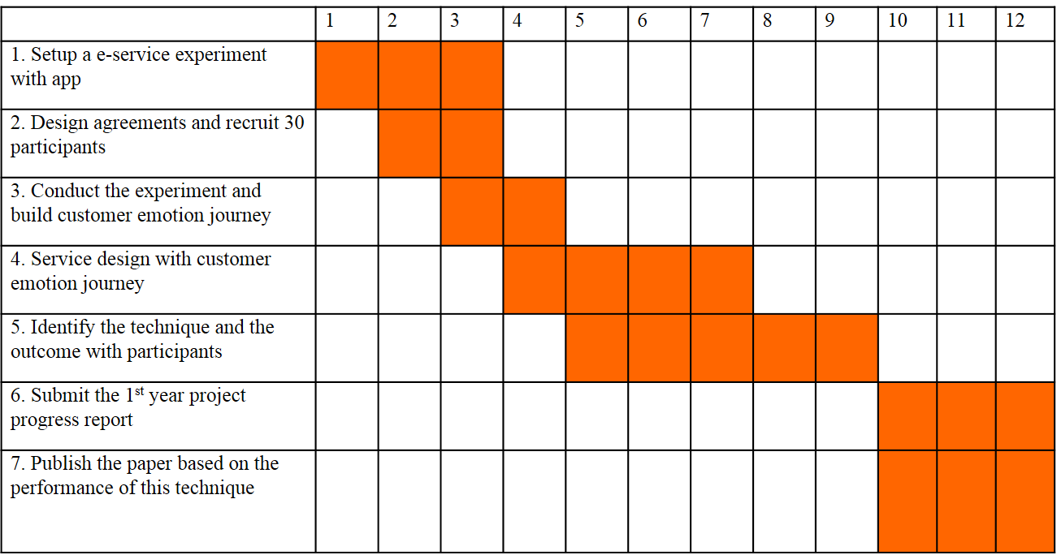

**5.2 Expected Results and Contributions**

In the past, the customer research techniques focused on the cues observed by researchers or got answers from customers after they experience the service. However, they found that sometimes we cannot stay around subjects because of interruption or bad feeling. Some techniques have been developed, such as shadowing or culture probe were developed to overcome such limitations. With these techniques, we can record the entire customer journey without interrupting them.

However, after we designed several services with the aforementioned techniques, we found that it is not only hard to record emotional states in customer experience journeys but also difficult to judge subjects’ emotion states only with the visual observation and limited knowledge of facial and behavioral emotional expression. It results in that we can only define partial feelings observed in some touch points. Because of these drawbacks, we have proposed this research to build an emotional state classification system which can be used for detecting users’ emotional states in service contexts. Moreover, due to the unobservable physical contexts in mobile service, we plan to adopt the developed techniques to online learning contexts, such as MOOC. A set of experiments are designed to evaluate the effectiveness of classification performance and learning achievement after the system is built.

The main results and contributions are summarized as follows.

1. We leverage the data captured by the EEG-based BCI wearable devise, we develop a time-based artificial neural network to classify different emotional sates, which is the basic technique for detecting users’ emotional state.
2. Based on the emotion recognition system and online learning scenarios, we could offer a new service to facilitate interaction in the e-service context via rigorous experimental design and testing.
3. We extend the service design methodology in discovering customers’ needs and prototype testing to equip BCI technologies to obtain direct users’ emotional state information for identifying the customers’ experiences in service encounters, and in turn, enable the development of new techniques to facilitate users’ interaction.
4. We expect to publish papers in the topics on emotion recognition via NeuroSky MindWave headset based on Time-based neural network and the effectiveness of facilitation in e-learning context. These results will benefit academic in service design and innovation research, and also the industries which intend to innovation new services with systematic manners.

**References**

Allen, J. J. B., et al. (2001). "Manipulation of frontal EEG asymmetry through biofeedback alters self-reported emotional responses and facial EMG." Psychophysiology **38**: 685-693.

Arslan, B., et al. (2006). A real time music synthesis environment driven with biological signals. ICASSP.

Bos, D. (2007). EEG-based emotion recognition. The Inﬂuence of Visual and Auditory Stimuli. Computer Science, University of Twente.

Bos, D. O. (2006). "EEG-based Emotion Recognition - The Influence of Visual and Auditory Stimuli." Emotion **57**(7): 1798-1806.

Bradley, M. M. and P. J. Lang (1994). "Measuring Emotion: The Self-assessment Manikin and the Semantic Differential " Journal of Behavior Therapy and Experimental Psychiatry **25**: 49-59.

Cahn, B. R. and P. John (2006). "Meditation states and traits: EEG, ERP, and neuroimaging studies." Psychological Bulletin **132 (2)**: 180-211.

Coan, J. and J. J. B. Allen (2004). "Frontal EEG asymmetry as a moderator and mediator of emotion." Biological Psychology **67**: 7-49.

Coles, et al. (1996) Event-related brain potentials: an introduction. 1-27

Damasio, A. R. (1998). "Emotion in the perspective of an integrated nervous system." Brain Research Reviews **26 (2)**: 83-86.

Doorn, J. and J. Hoekstra (2013). "Customization of online advertising: The role of intrusiveness." Marketing Letters **24**(4): 339-351.

Ertl, M. (2013). "Emotion regulation by cognitive reappraisal — The role of frontal theta oscillations." NeuroImage **81**: 412-421.

Garrett, D., et al. (2003). "Comparison of linear, nonlinear, and feature selection methods for EEG signal classification." Neural Systems and Rehabilitation Engineering, IEEE Transactions on **11**(2): 141-144.

Han, J. W. (2005). Data mining: concepts and techniques. Singapore, Morgan kaufmann.

Haselsteiner, E. and G. Pfurtscheller (2000). "Using Time-Dependent Neural Networks for EEG Classification." IEEE TRANSACTIONS ON REHABILITATION ENGINEERING **8**: 457-463.

Henriques, J. B. and R. J. Davidson (1991). "Left Frontal Hypoactivation in Depression " Journal of Abnormal Psychology **100**: 535-545.

Huettel, S. A., et al. (2009). Functional Magnetic Resonance Imaging. Massachusetts, Sinauer.

Jain, A. K., et al. (1996). "Artificial neural networks: a tutorial." Computer **29**(3): 31-44.

Klimesch, W. (1999). "EEG alpha and theta oscillations reflect cognitive and memory performance: a review and analysis." Brain Research Reviews **29**(2–3): 169-195.

Kottaimalai, R. (2013). EEG Signal Classification using Principal Component Analysis with Neural Network in Brain Computer Interface Applications. IEEE International Conference on Emerging Trends in Computing, Communication and Nanotechnology**:** 227-231.

Kottaimalai, R., et al. (2013). EEG Signal Classification using Principal Component Analysis with Neural Network in Brain Computer Interface Applications. IEEE International Conference on Emerging Trends in Computing, Communication and Nanotechnology**:** 227-231.

Kumar, V. (2012). Design Method: A STRUCTURED APPROACH FOR DRIVING INNOVATION IN YOUR ORGANIZATION. New Jersey, John Willy & Sons.

Lang, P. J. and M. M. Bradley (2007). Handbook of Emotion Elicitation and Assessment, Oxford University Press.

Larsen, E. A. (2011). Classification of EEG Signals in a Brain-Computer Interface System. Master of Science in Computer Science, Norwegian University of Science and Technology.

Murugappan, M. and S. Murugappan (2013). Human emotion recognition through short time Electroencephalogram (EEG) signals using Fast Fourier Transform (FFT). IEEE International Colloquium on Signal Processing and its Applications 9th**:** 289-294.

NEUROSKY (2009) Brain Wave Signal (EEG)

Niedermeyer, E. and F. L. d. Silva (2004). Electroencephalography: Basic Principles, Clinical Applications, and Related Fields, Lippincot Williams & Wilkins.

Niemic, C. P. (2002). "Studies of emotion: A theoretical and empirical review of psychophysiological studies of emotion." Journal of Undergraduate Research **1**: 15-18.

Peng, H., et al. (2011). User-centered depression prevention: An EEG approach to pervasive healthcare. Pervasive Computing Technologies for Healthcare (PervasiveHealth), 2011 5th International Conference on.

Pfurtscheller, G. and F. H. Lopes Da Silva (1999). "Event-related EEG/MEG synchronization and desynchronization: Basic principles." Clinical Neurophysiology **110 (11)**: 1842-1857.

Pine, I. I. B. J. and J. H. Gilmore (1998). "WELCOME TO THE EXPERIENCE ECONOMY." Harvard Business Review **76**(4): 97-105.

First there was agriculture, then manufactured goods, and eventually services. Each change represented a step up in economic value--a way for producers to distinguish their products from increasingly undifferentiated competitive offerings. Now, as services are in their turn becoming commoditized, companies are looking for the next higher value in an economic offering. Leading-edge companies are finding that it lies in staging experiences. To reach this higher level of competition, companies will have to learn how to design, sell, and deliver experiences that customers will readily pay for. An experience occurs when a company uses services as the stage--and goods as props--for engaging individuals in a way that creates a memorable event. And while experiences have always been at the heart of the entertainment business, any company stages an experience when it engages customers in a personal, memorable way. The lessons of pioneering experience providers, including the Walt Disney Company, can help companies learn how to compete in the experience economy. The authors offer five design principles that drive the creation of memorable experiences. First, create a consistent theme, one that resonates throughout the entire experience. Second, layer the theme with positive cues--for example, easy-to-follow signs. Third, eliminate negative cues, those visual or aural messages that distract or contradict the theme. Fourth, offer memorabilia that commemorate the experience for the user. Finally, engage all five senses--through sights, sounds, and so on--to heighten the experience and thus make it more memorable. [ABSTRACT FROM AUTHOR]

Harvard Business Review Notice of Use Restrictions, May 2009Harvard Business Review and Harvard Business Publishing Newsletter content on EBSCOhost is licensed for the private individual use of authorized EBSCOhost users. It is not intended for use as assigned course material in academic institutions nor as corporate learning or training materials in businesses. Academic licensees may not use this content in electronic reserves, electronic course packs, persistent linking from syllabi or by any other means of incorporating the content into course resources. Business licensees may not host this content on learning management systems or use persistent linking or other means to incorporate the content into learning management systems. Harvard Business Publishing will be pleased to grant permission to make this content available through such means. For rates and permission, contact permissions@harvardbusiness.org. (Copyright applies to all Abstracts.)

Sahito, F. and S. Wolfgang (2012). "Functional Magnetic Resonance Imaging and the Challenge of Balancing Human Security with State Security." Human Security Perspectives **1**: 38-66.

Seo, S., et al. (2008). The relation between affective style of stressor on EEG asymmetry and stress scale during multi-modal task. Third 2008 International Conference on Convergence and Hybrid Information Technology**:** 461-466.

Spengler, C., et al. (2010) 360-Degree-Touchpoint-Management - How important is twitter for our brand? Content published in: Marketing Review 14-20

Stickdorn, M. and J. Schneider (2010). THIS IS SERVICE DESIGN THINKING. Netherland, BIS Publishers.

Subasia, A. and E. Ercelebi (2005). "Classification of EEG signals using neural network and logistic regression." Computer Methods and Programs in Biomedicine **78**: 87-99.

Tatum, W. O., et al. (2008). Handbook of EEG Interpretation, Demos Medical.

Vidal, J. (1973). "Toward direct brain-computer communication." Annual review of biophysics and bioengineering **2**: 157-180.

Vladimir, F., et al. (2001). "Multiplicity of the α Rhythm in Normal Humans." Journal of Clinical Neurophysiology **18 (4)**: 331-344.

Wolpaw, J. R., et al. (2002). "Brain–computer interfaces for communication and control." Clinical Neurophysiology **113**(6): 767-791.

Xu, H. and K. N. Plataniotis (2012). Affect recognition using EEG signal. Multimedia Signal Processing (MMSP). Banff, AB**:** 299-304.

Yoon, H. (2013). "Emotion Recognition of Serious Game Players Using a Simple Brain Computer Interface." IEEE ICTC: 783-786.

Yuan, Y., et al. (2008). Delay Time-Based Epileptic EEG Detection Using Artificial Neural Network. Bioinformatics and Biomedical Engineering**:** 502-505.

Yuen, C. T., et al. (2009). "Classification of Human Emotions from EEG Signals using Statistical Features and Neural Network." International Journal of Integrated Engineering **1**(3): 71 - 79.

Zhang, Y., et al. (2011). "Identifying Cognitive Preferences for Attractive Female Faces: An Event-Related Potential Experiment Using a Study-Test Paradigm." Journal of Neuroscience Research **89**: 1887-1893.